Contents

OVERVIEW:- 2

How to download Postman Collections 3

How to download CSV files 5

RegressionTest_PartB_PartD_LTCcosts for FP-R1.4 contains seven CSV files to be downloaded 5

RegressionTest_PartB_PartD_Surcharge requires one csv file to be downloaded. 5

Surcharge_Validation_input (51*4).csv to the user system. 5

How to download Environments 5

Set up Postman and Run the tests 6

How to Import the Collections into Postman 6

How to Import Environments to Postman. 8

How to Run and Validate the Response body for BaseLine_FunctionalTest for FP-R1.4 Collection in Postman. 9

How to Run and Validate the Response body for RegressionTest_PartB_PartD_LTCcosts for FP-R1.4 Collection in Postman. 11

How to Run and Validate the Response body for RegressionTest_PartB_PartD_Surcharge for FP-R1.4 Collection in Postman. 20

# **OVERVIEW:-**

The purpose of this document is to explain how to perform Functional Test and Regression Test for Financial Planner Release 1.4. These test cover the following seven API's.

1. individualPreMedicareR3
2. individualMedicareR3
3. individualTotalExpensesR3
4. familyPreMedicareR3
5. familyMedicareR3
6. familyTotalExpensesR3
7. longTermCareR4

**Functional Testing** is meant to perform testing to verify that each **function** of the API operates in conformance with the requirement specification.

**Regression Testing** is meant to ensure that API will work for all possible input data for positive test. For example, we will test the part B premium for several thousand zip-codes across united states covering all states. Another example will be to make sure that surcharge for Part B and D is being calculated for all states in US.

Perform three different postman collections tests. One collection for functional test and two collections for regression test.

* Postman collection BaseLine_FunctionalTest for financial planner release 1.4 (FP-R1.4) will test seven API stated below.
  + individualPreMedicareR3
  + individualMedicareR3
  + individualTotalExpensesR3,
  + familyPreMedicareR3,
  + familyMedicareR3
  + familyTotalExpensesR3,
  + longTermCareR4
* Postman collection RegressionTest_PartB_PartD_LTCcosts for FP-R1.4 will do the regression test for seven API's
  + individualPreMedicareR3
  + individualMedicareR3
  + individualTotalExpensesR3,
  + familyPreMedicareR3,
  + familyMedicareR3
  + familyTotalExpensesR3,
  + longTermCareR4
* Postman collection RegressionTest_PartB_PartD_Surcharge for FP-R1.4 will do the surcharge regression test the four API's
  + individualMedicareR3,
  + individualTotalExpensesR3,
  + familyMedicareR3,
  + familyTotalExpensesR3)

Scope of this document is to explain the process to execute the following three steps:

1. How to Import the Collections to Postman.
2. How to Run the Collection.
3. How to verify the output in Pre-Requisite

Before user can run any tests, they have to download the files needed. Three kind of files need to be download.

1. Download Postman Collections
2. Download CSV files
3. Download Environments

## **How to download Postman Collections**

From AiVante google drive >FPBaseline_Regression_SurchargeValidation-R1.4 download all the three collections.

* BaseLine_FunctionalTest for FP-R1.4P-R1.4
* RegressionTest_PartB_PartD_LTCcosts for FP-R1.4
* RegressionTest_PartB_PartD_Surcharge for FP-R1.4

**Please use the link below to download the collections**

<https://drive.google.com/drive/folders/1PeNU3azio2a6c6uLOSxbQUoZxb3oaKVn?usp=sharing>

## **How to download CSV files**

From Aivante google drive>FPBaseline_Regression_SurchargeValidation-R1.4>CSV_files folder download the csv files.

Please use the link below to download the CSV files

<https://drive.google.com/drive/folders/1PeNU3azio2a6c6uLOSxbQUoZxb3oaKVn?usp=sharing>

### RegressionTest_PartB_PartD_LTCcosts for FP-R1.4 contains seven CSV files to be downloaded

1. LTC_3140_zipcodes.csv

2. individualTotalExpensesR3_input.csv

3. individualPreMedicare_input(3140).csv

4. individualMedicareR3_input.csv

5. familyTotalExpensesR3_input.csv

6. familyPreMedicareR3_input.csv

7.familyMedicareR3_input.csv

### RegressionTest_PartB_PartD_Surcharge requires one csv file to be downloaded.

### Surcharge_Validation_input (51*4).csv to the user system.

Once the download is complete organize the Collections and CSV files in separate folders in the user system.

## **How to download Environments**

From AiVante google drive>FPBaseline_Regression_SurchargeValidation-R1.4>FP Environment download all the four Environments.

Please use the link below to download the Environment files.

<https://drive.google.com/drive/folders/1PeNU3azio2a6c6uLOSxbQUoZxb3oaKVn?usp=sharing>

1. FP local.postman_environment.json
2. FP dzeepublicPlan.postman_environment.json
3. FP dzanalytics.postman_environment.json
4. FP Advicent.postman_environment.json to the user system.

# **Set up Postman and Run the tests**

Importing collection, setting up the environment and running the tests. All these steps are described in this section.

## **How to Import the Collections into Postman**

* Go to Postman click on Import button on the top left side.

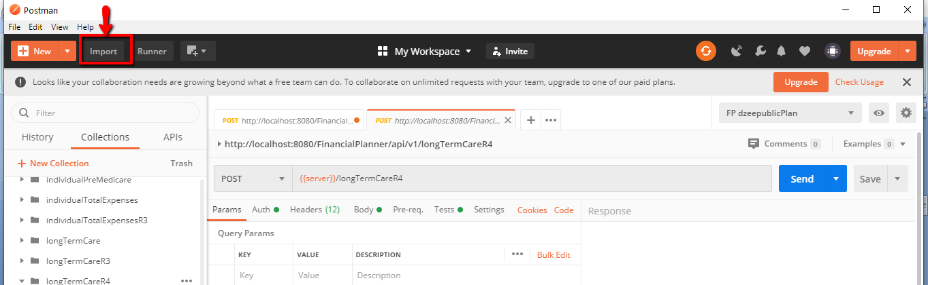

* Then IMPORT window opens. Click on choose files

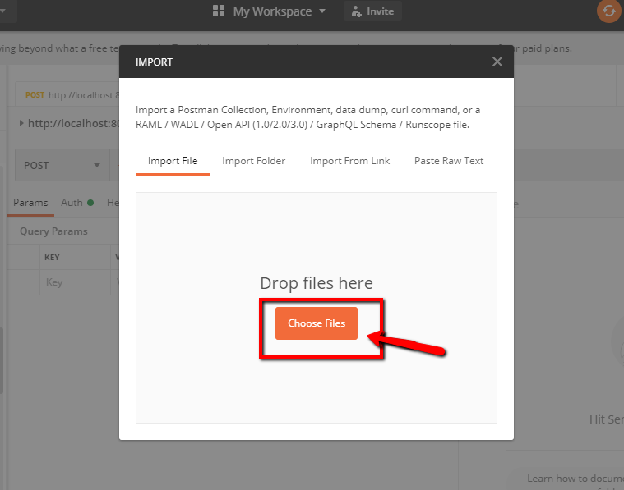

* Then select the three **1.BaseLine_FunctionalTest for FP-R1.4**

**2.RegressionTest_PartB_PartD_LTCcosts for FP-R1.4**

**3.RegressionTest_PartB_PartD_Surcharge for FP-R1.4** Postman

collection files from the user system and click open.

* The collections will import to the Postman successfully. We will find the three imported collections on the left side under collections as seen in the screenshot below.

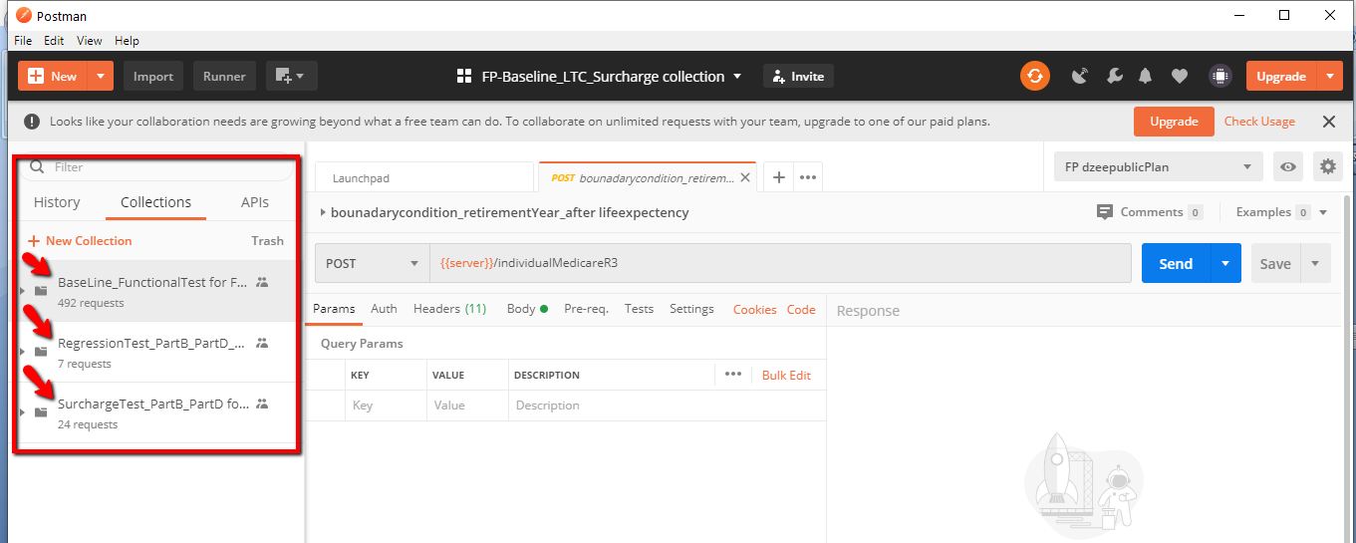

## **How to Import Environments to Postman.**

* Go to Postman click on Import button on the top left side.



* Then IMPORT window opens. Click on choose files.



* Then select the four **1.FP local.postman_environment.json**

**2.** **FP dzeepublicPlan.postman_environment.json**

**3.** **FP dzanalytics.postman_environment.json**

**4.** **FP Advicent.postman_environment.json** Environments files from

the user system and click open.

* The Environments will import to the Postman successfully. We will find the four imported Environments under the dropdown on the right side as seen in the screenshot below.

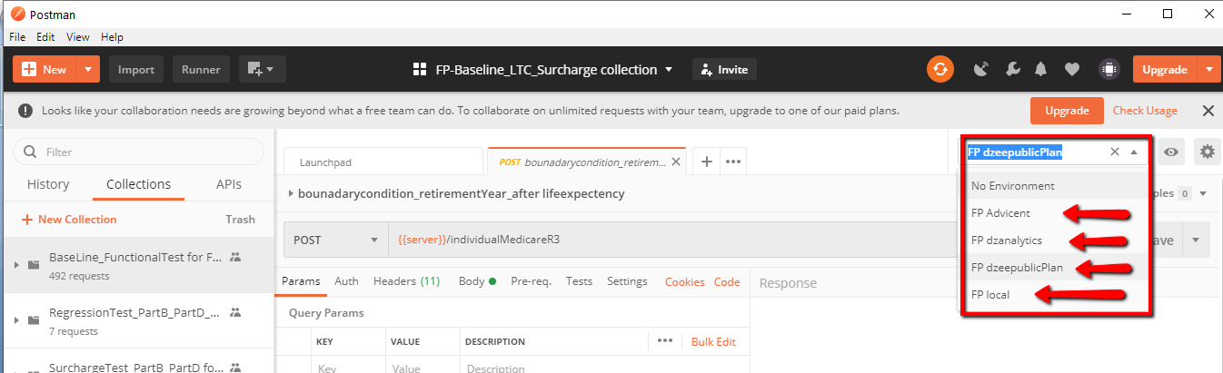

## **How to Run and Validate the Response body for BaseLine_FunctionalTest for FP-R1.4 Collection in Postman.**

* Click on the Runner tab on the top left side.

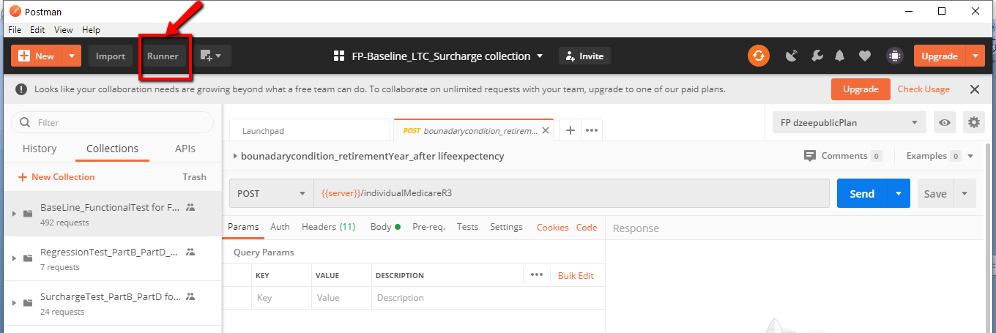

* Select the **BaseLine_FunctionalTest for FP-R1.4** collection under All Collections as shown in the below screen shot.

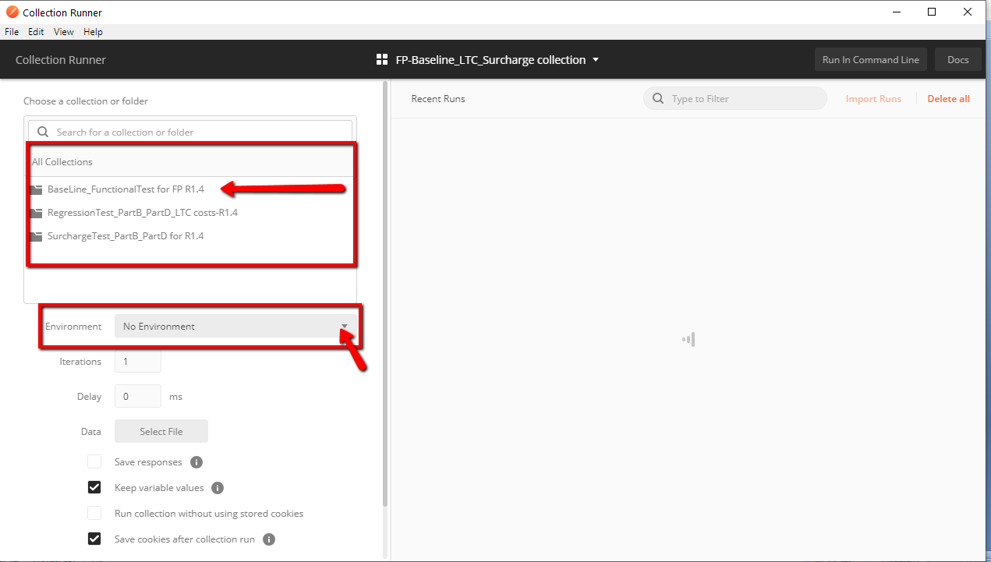

* Choose the environment from the dropdown in which the user wants to run these tests as shown from the above screen shot.
* Click on Start Run.

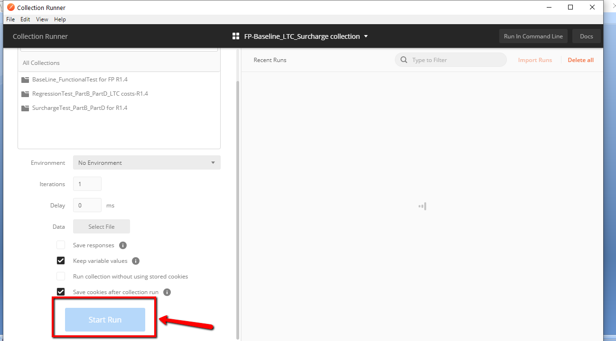

* It will execute the test cases and validates the data. It takes approximately 3minutes as shown in the below screenshot.

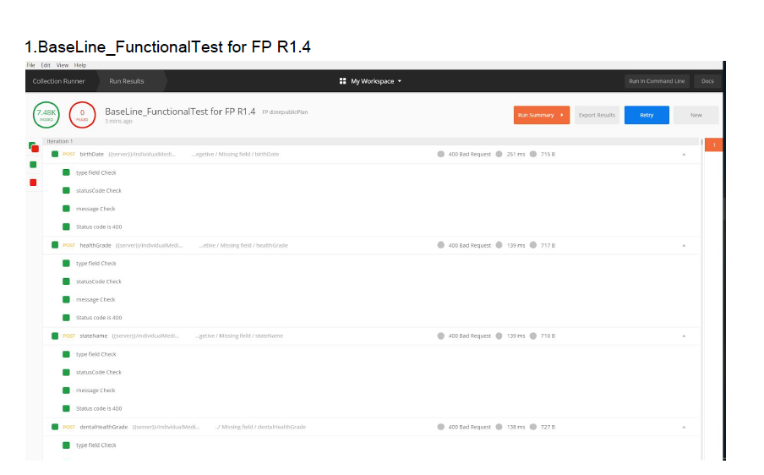

* All the seven API’s response body fields are validated.

In each API there are two types of Test cases, Negative and Positive .

* In Negative, there are invalid, missing and empty field testcases. The fields are validated by providing **invalid data as input**. It checks whether the application is behaving as expected with the negative inputs.
* In Positive, the fields are validated by providing the **valid data** **as input.** This test is done to check whether the application is doing what it is supposed to do.

## **How to Run and Validate the Response body for RegressionTest_PartB_PartD_LTCcosts for FP-R1.4 Collection in Postman.**

* Click on the Runner tab on the top left side.



* Select the **RegressionTest_PartB_PartD_LTCcosts for FP-R1.4**

collection under all collections as shown in the below screen shot.

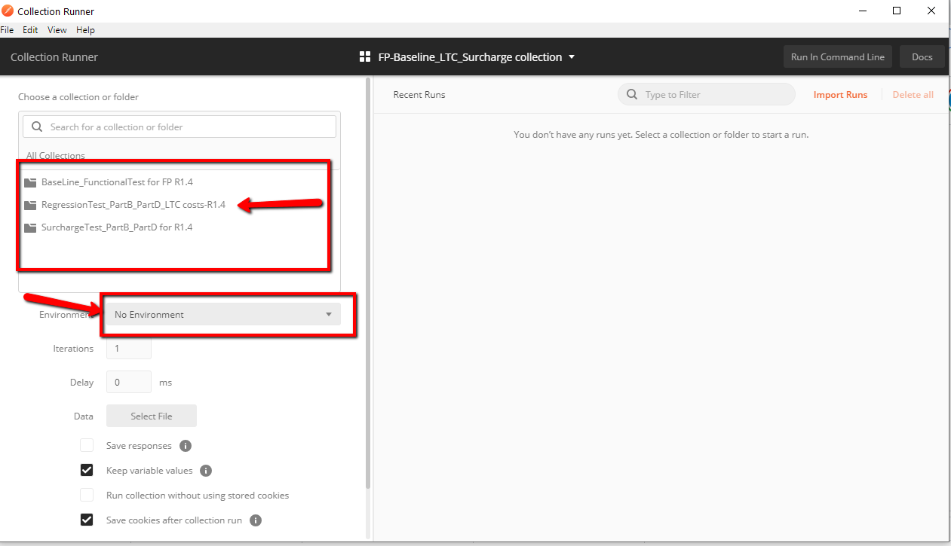

* Choose the environment from the dropdown in which the user wants to run these tests as shown from the above screen shot.
* Select file as shown in the below screen shot. It takes you to file location.

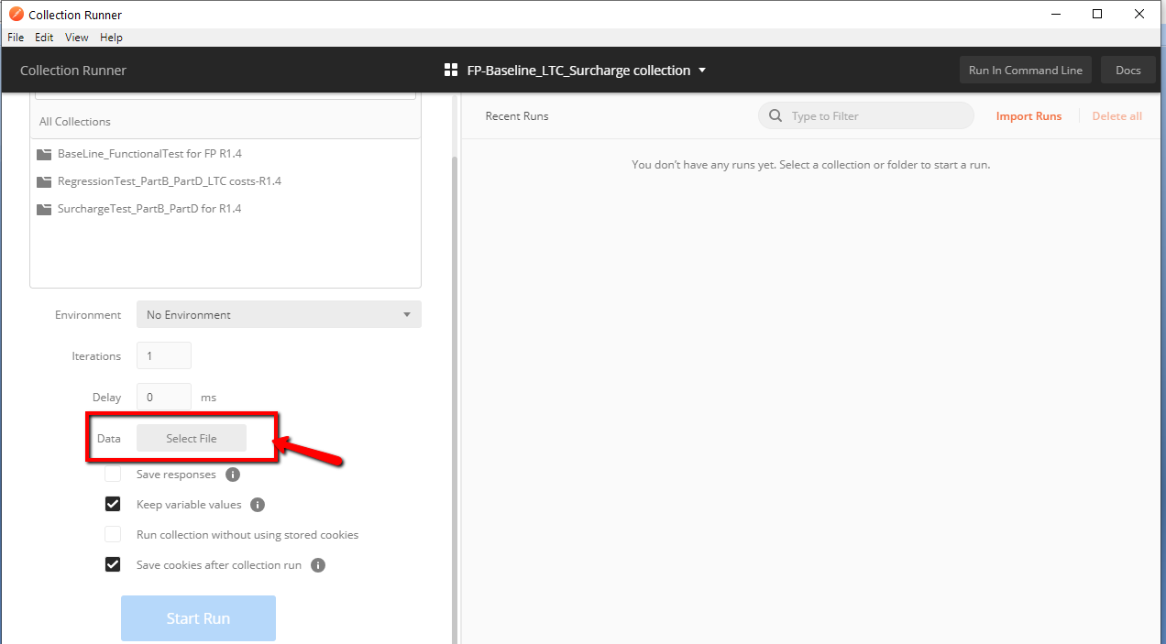

* Choose the relevant .csv file from the user system and click open.

Ex:- If you are running individualMedicare API, choose individualMedicare_input.csv file

(contains endpoint and state for 3140 zip codes)

* Click on Start Run.



* It will execute the test cases and validates the data. It takes approximately 10-20 minutes as shown in the below screenshots.

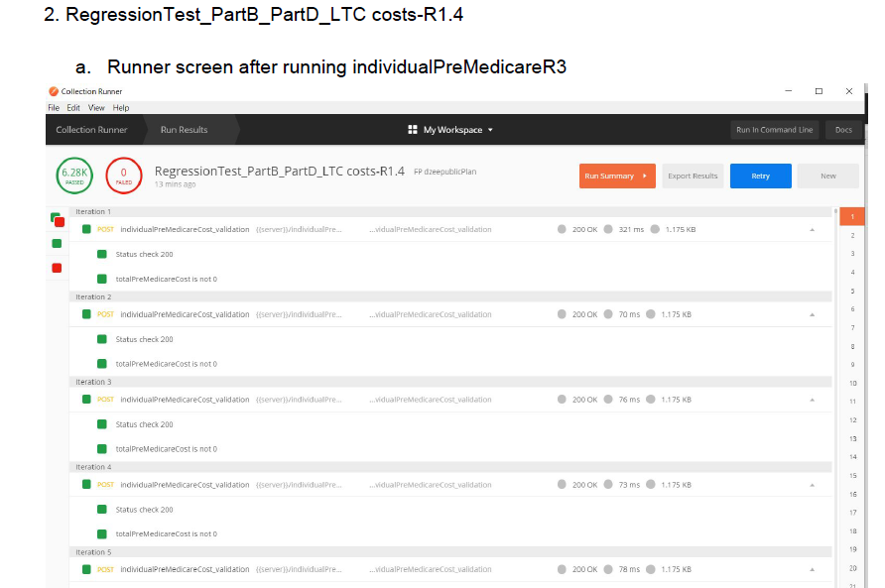

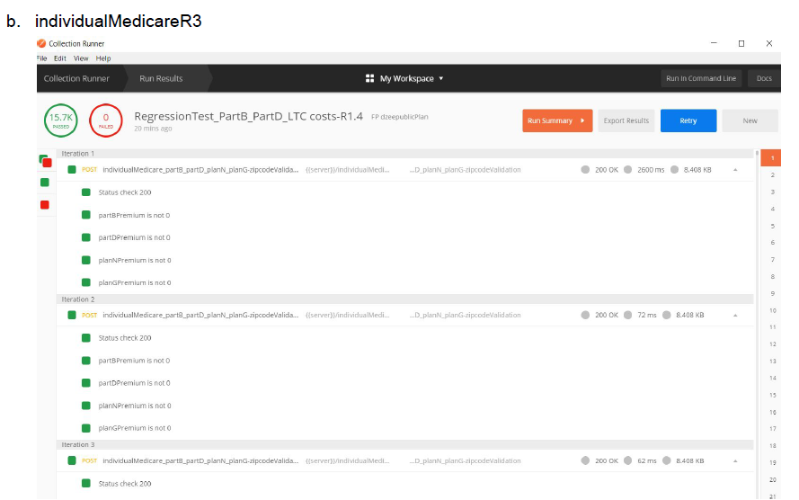

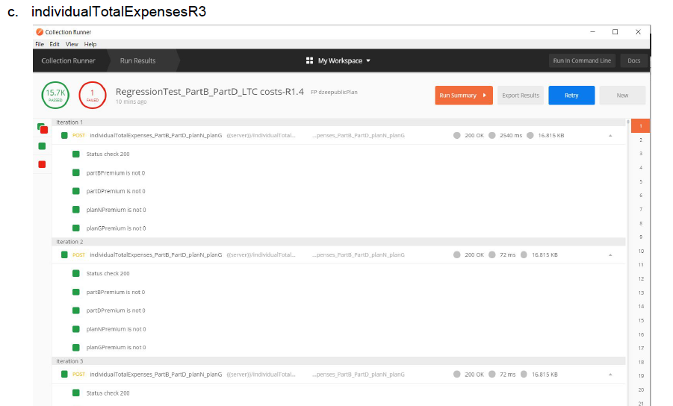

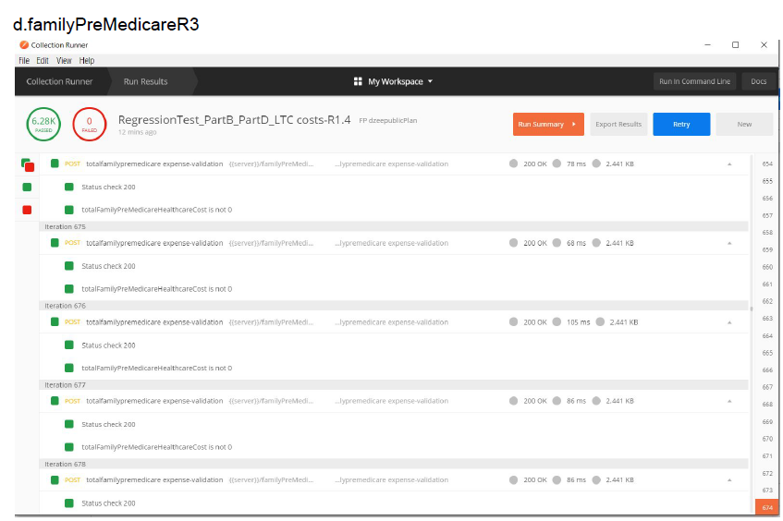

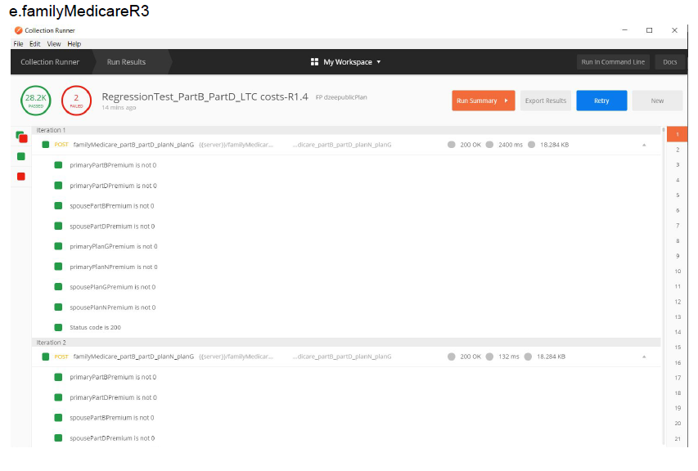

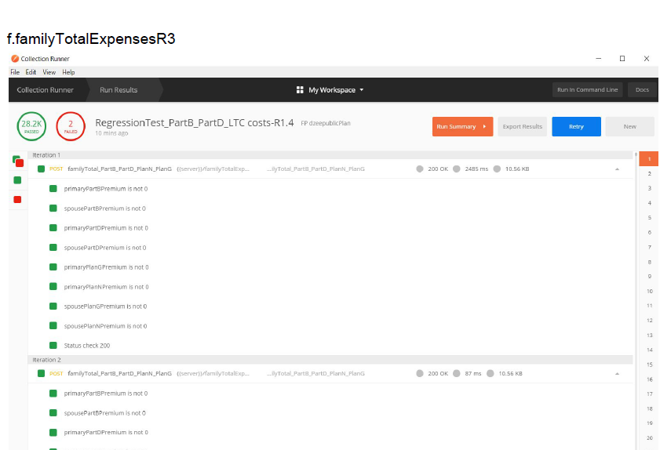

**g.longtermcareR4** 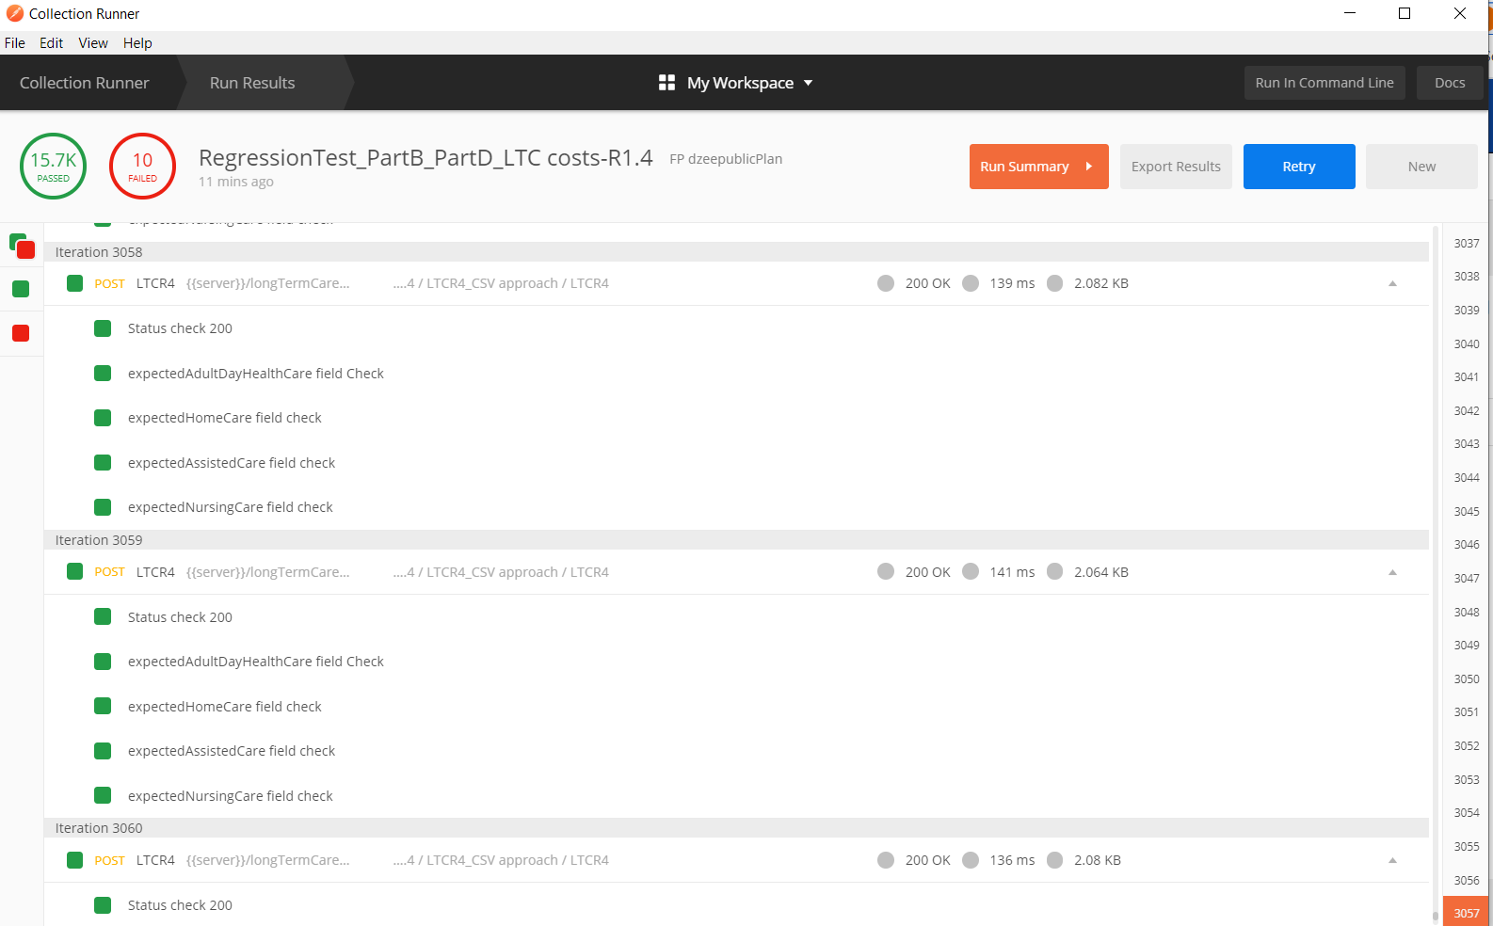

* Repeat this process for all the seven API's.

**1.individualPreMedicareR3**

**2.individualMedicareR3**

**3.individualTotalExpensesR3**

**4.familyPreMedicareR3**

**5.familyMedicareR3**

**6.familyTotalExpensesR3**

**7.longTermCareR4**

* The API **individuaPreMedicareR3** validates the fields of total PreMedicare cost as nonzero and the API **familyPreMedicareR3** validates the fields of total family PreMedicare healthcare Cost as non zero in their response body.

**Note:-** Currently the costs are checked for the year 2020 and the subsequent release of the documentation and the collection we will make this check for the variable year(Mostly the current year).

* Rest of the five API”s

**1. individualMedicareR3**

**2.individualTotalExpensesR3**

**3.familyMedicareR3**

**4.familyTotalExpensesR3**

**5.longTermCareR4**

validate the values of Part B premium, Part D premium, Plan G premium

and Plan N premium values, that they are non zero in their response body.

## **How to Run and Validate the Response body for RegressionTest_PartB_PartD_Surcharge for FP-R1.4 Collection in Postman.**

* Click on the Runner tab on the top left side.



* Select the **RegressionTest_PartB_PartD_Surcharge for FP-R1.4** collection under All Collections as shown in the below screen shot.

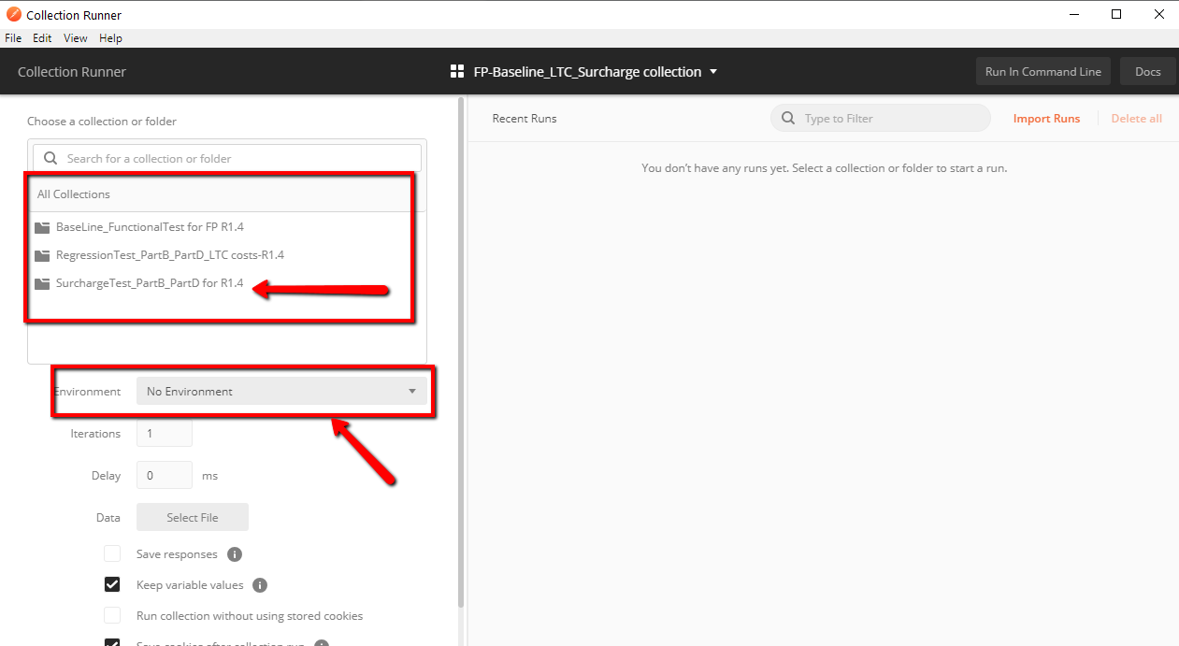

* Choose the environment from the dropdown in which the user wants to run these tests as shown from the above screen shot.
* Select file as shown in the below screen shot. It takes you to file location.



* Choose the relevant.csv file(Surcharge_input(51x4) from the user system and click open.
* Click on Start Run.



* It will execute the test cases and validates the data. It takes approximately 34 minutes as shown in the below screenshots.

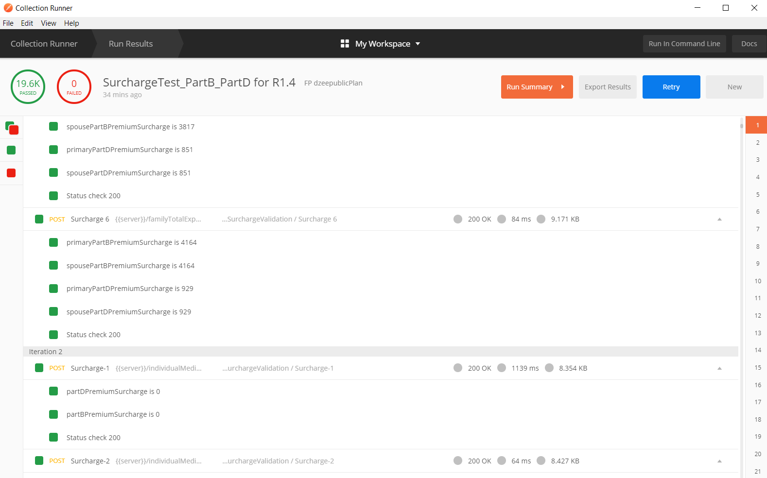

For the following four API’s

**1.individualMedicareR3**

**2.individualTotalExpensesR3**

**3.familyMedicareR3**

**4.familyTotalExpensesR3** the surcharge depending upon their magi tier value (1-6)is validated in their response body.